**Winter**

12

**Brigham Young University School of Technology**

08

**Fall**

Headset Display Planetarium Prototype

User Manual

Team Pancake: Lehi Alcantara, Michael Hughes. Kellie Kercher, Ian McGuire, Owen Riley

# 

Table of Contents

Hardware Setup 3

Opening the Application 3

Using the Control 4

Reading the Log File 6

## Hardware Setup

The Vuzix Tac-Eye glasses require two connections to the laptop, a VGA and a USB for power. The Dell Latitude E6220 only has 2 USB connections and thus a USB Port Hub is required. For user testing, if using the laptop’s monitor and the AR glasses, no USB to VGA adapter is needed, just the USB Port Hub. If during user testing connection to a projector is required, use the USB to VGA adapter. Connect the USB Port Hub to the laptop and then connect the AR glasses, the Mouse and the USB to VGA adapter to the USB Port Hub. Configure the display settings so that the projector and the laptop monitor are mirrored and the AR glasses act as a second display.

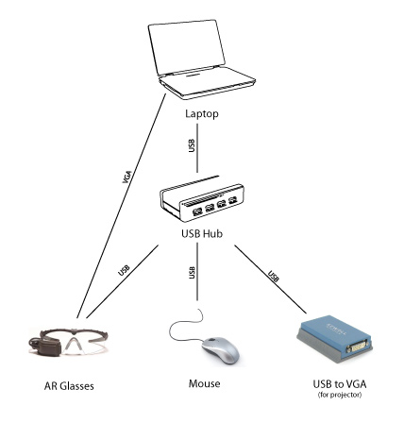

## Opening the Application

Selecting Test.exe can open the application. This can be found inside the directory ARI. Once open, select a video for both the main and ASL videos. If a video is not provided, the application will not continue.

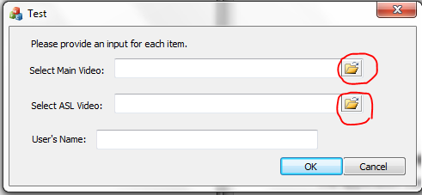

With both video inputs provided, enter in the Test Subject’’s first and last name only.

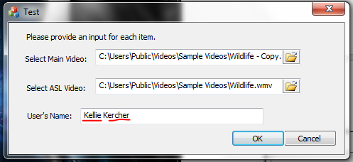

After pressing “OK” the videos along with the ASL video controls will open.

## Using the Control

Below is a picture of the user controls. These controls can be used to manipulate the ASL interpreter along with controlling the play of both video files.

## 

**1. Play/Pause:** This button will play or pause both videos.

**2. Zoom:** This slider will zoom in or zoom out on the interpreter video. Sliding to the left will zoom out; sliding to the right will zoom in.



**3. Brightness:** This slider controls the brightness of the ASL video. Sliding to the left will decrease brightness, sliding to the right will increase brightness.



**4. Contrast:** This slider controls the contrast of the ASL video. Sliding to the left will decrease contrast, sliding to the right will increase contrast.



**5. Position Pointers:** These buttons will move the position on the interpreter in the video box. The arrows coordinate with the direction the interpreter will move when clicked.

## Reading the Log File

The application is automatically set to record all of the users interactions with the controls into a Microsoft Excel log file (CSV file). No additional configurations are needed. The log file will be stored inside the Log folder within the ARI folder.

CSV file format will allow the data to be searched through. Excel will interpret the comma-separated values as columns. The end of a line in the CSV file represents a row. There is a header line included with each file to remind viewers what is recorded. The example below shows how the file appears in Excel:

|  |  |  |  |  |  |  |  |  |
| --- | --- | --- | --- | --- | --- | --- | --- | --- |
| Zoom | Brightness | Contrast | Left Pos. | Top Pos. | Right Pos. | Bottom Pos. | Video Time | Computer Time |
| 0.5 | 0 | 0.5 | 0 | 0 | 550 | 700 | 0:00:01 | 3:14:30 |
| 0 | -1 | 0 | -30 | -30 | 520 | 670 | 0:00:03 | 3:14:32 |
| 1 | 1 | 1 | 30 | 30 | 580 | 730 | 0:00:05 | 3:14:34 |

The variables have a range of:

Zoom & Contrast (0,1)

Brightness (-1,1)

Left, Top, Right, Bottom Position (-∞,∞)

Video Time (0:0:0, ∞)

Computer Tim (0:0:0, 23:59:59)